# Dynamic poster

Tim Grevendonk

R0831309@student.thomasmore.be

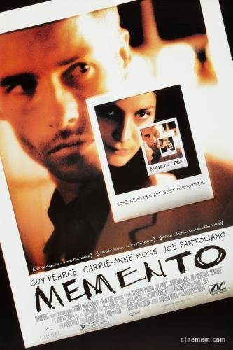

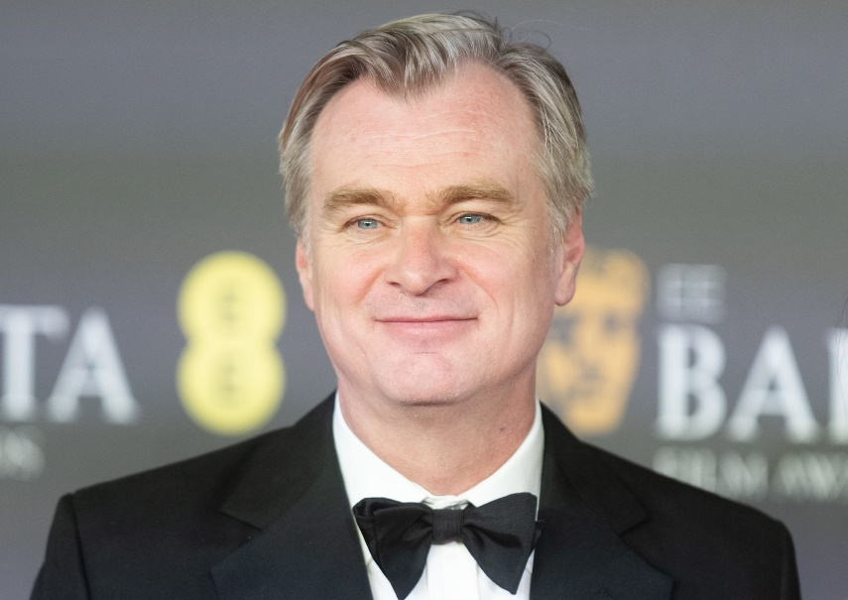

Memento

Christopher Nolan

Content

Dynamic poster 1

Christopher Nolan 3

biography 3

Memento 3

plot 3

structure 3

visuals 4

style characteristics 4

Moodboards 5

Colour moodboard 1 5

Colour moodboard 2 6

Rough concepts 7

Concept 1 7

Concept 2 7

Concept 3 8

Concept 4 8

Concept 5 9

Illustration styles 10

Style 1 10

Style 2 11

Style 3 11

Style 4 12

## Christopher Nolan

### biography

is a British and American film producer that is very known of making complex movie stories. He is one of the most influential film producers known, and among the highest grossing directors in history. He has earned many awards with his movies being 2 academy awards among them.

## Memento

### plot

The actor Guy Pearce plays a man called “Leonard Shelby” that suffers from a condition where he cannot make or keep new memories from after an accident he suffered. The condition is a type of amnesia in short term memories. With a complex method of polaroid pictures, tattoos and handwritten notes he made a system to try and remember everything that happens before in order to find his wives’ killer. He encounters people in the movie that he must remember by these pictures and notes and based on their tracked data deduce if they are trustable and an asset to his goal to track down his target, this will be to find out again and again that he is being targeted too by people that take advantage of his condition or have no sympathy for it.

### structure

The movie starts with its end, each time pacing back into the “memories” of what happened before every time being a section where he forgot and has to deduce what happened before. Also there is a part of memories that does follow chronological order in black-and-white. these scenes combine in the end of the movie to form the solution to the pot and mission he has been going through.

### visuals

The movie follows the style of neo-noir setup and visuals. these are crime dramas with a tone from the great depression and mostly or partially shot in black-white. The tone of the movie is a darker tone what hard contrasts of different scenes and contexts (like the black-and-white VS current time and coloured setups). The main characteristics to be correlated with Neo-noir are the feeling of angst and uncertainty where the protagonist falls into an obsession with his wife and redemption for her. The protagonist is only the hero in his own story and knows no ideals only goals where society is brutally hard on him due to the corruption of people and the vague line between good and bad. Due to the domain of the movie having a complicated story and the world is setup against them, there is often no happy ending.

### style characteristics

* Strong contrast between scenes
* lighting and emphasis towards a character.
* use of voice overs (the talk of memories)

## Moodboards

The movie follows the setting and tone of neo-noir, this means that elements of black and white are heavily used with signs of depression and bleak outcomes in the storyline. Putting the style era in neo (meaning new) means that the heavy greyscale use is often abandoned or used as only special effect or tonal shifts.

To try and discover multiple methods of colour theory that could work together with the illustration styles multiple moodboards have been created. Further description for each is provided.

### Colour moodboard 1

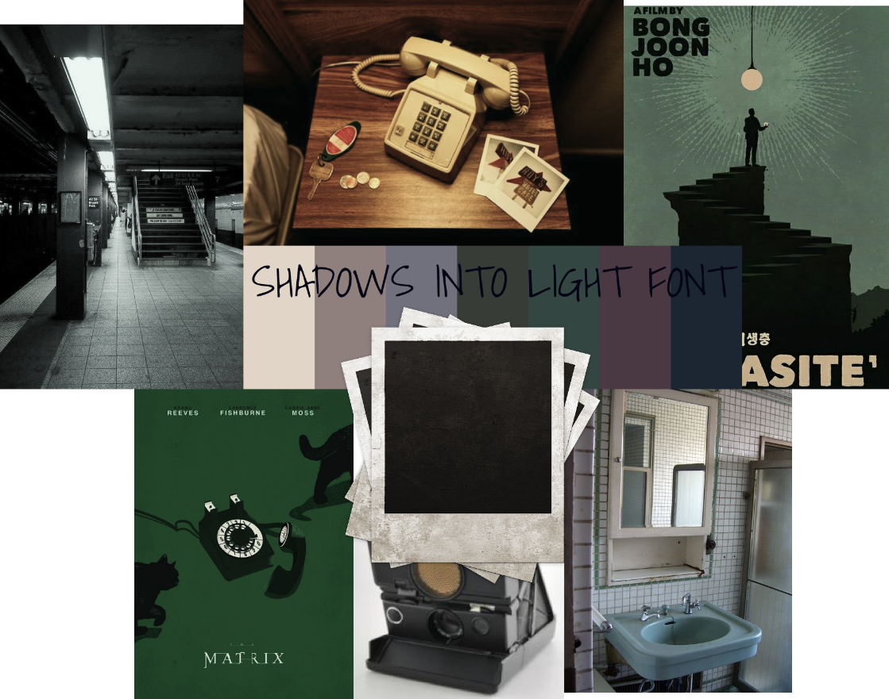

The use of bleak colours is used like in the movie. Some elements can be greyscale following the memory sequences. The colour pallet has muted colours that represent Los Angeles motels, neighborhoods, and desert like areas. Some illustration styles have been added to guide colour matching. The typography mimics the handwriting of the protagonist style of using capital letters.

### Colour moodboard 2

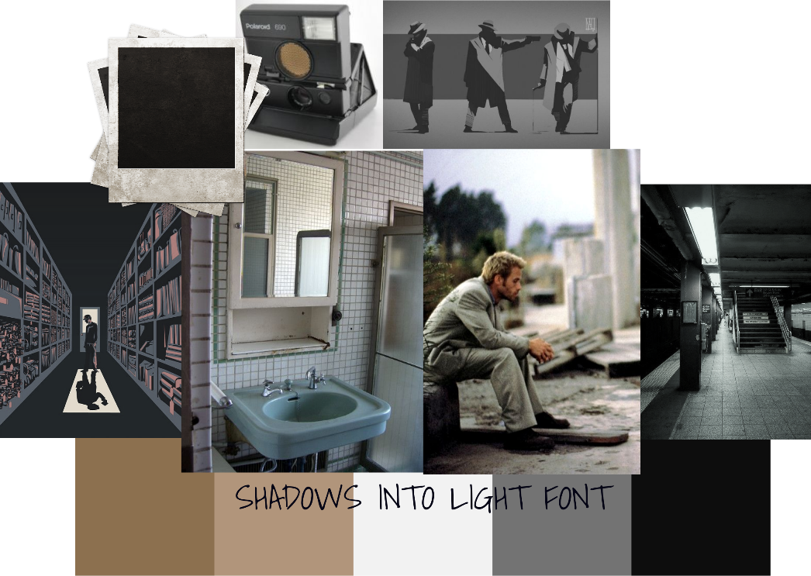

Here a more greyed pallet is used with beige tones to accentuate the skin of the protagonist and the Los Angeles daytimes. Greyscale leans more towards the classic noir style and works together with the memory segments in the movie. Darker colours also convey the mood of the negative spiral the movie sets the protagonist in.

## Rough concepts

### Concept 1



Multiple versions of the protagonist behind him depicting memories fading with polaroids flowing away out of the heads. In front is a polaroid showing what he only remembers now.

### Concept 2

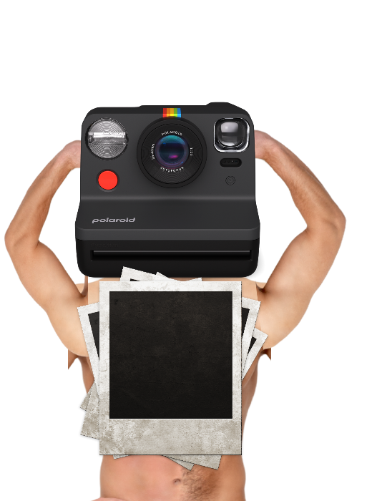

The protagonist holds the polaroid camera in front of his face in front of a mirror showing his tattoos. When he takes a picture it comes out switching the text from “Truth” to “Lies” each time a polaroid prints out.

### Concept 3

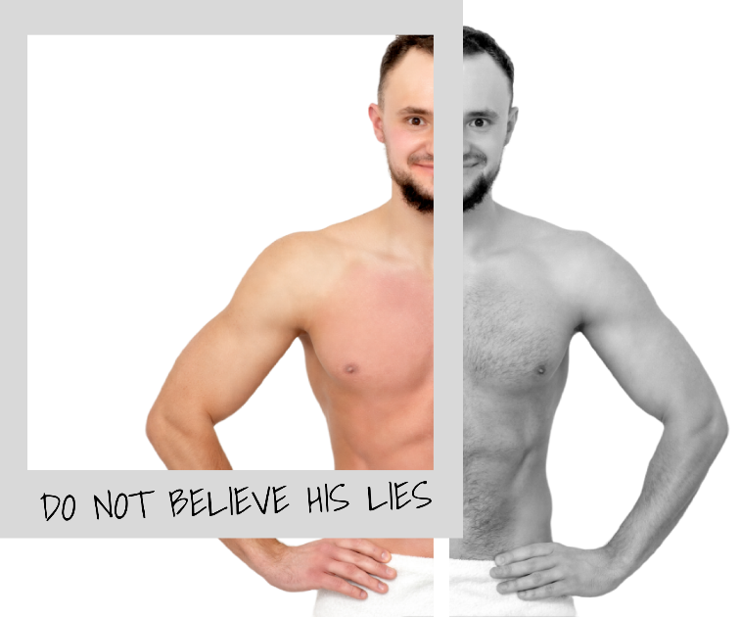

The protagonist half in a polaroid with the parts within it have colours to depict current memories, the parts outside it are in grey for the things hoe does not remember. The tattoos in the polaroid are clear, those outside it are blurred by circling scribbles.

### Concept 4

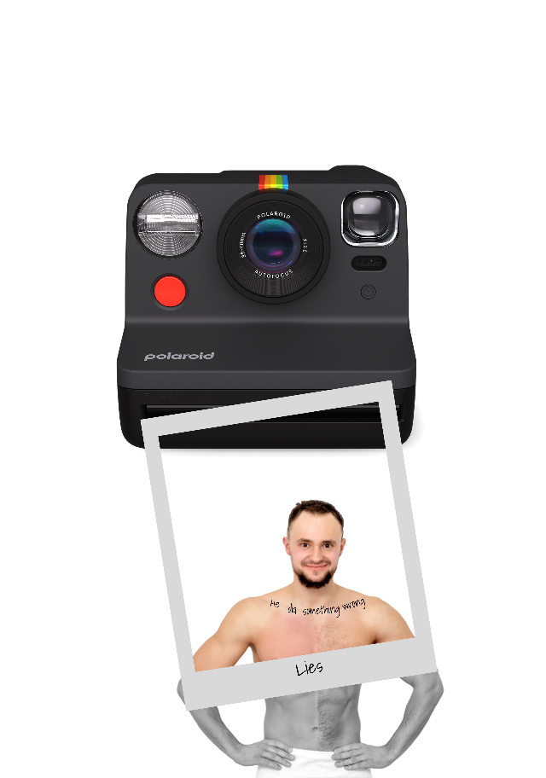

The protagonist stands under a polaroid camera in greyscale. each time a picture flashes and prints it falls down he is highlighted behind the polaroid. Everything inside the polaroid is clear depicting his current memories.

### Concept 5

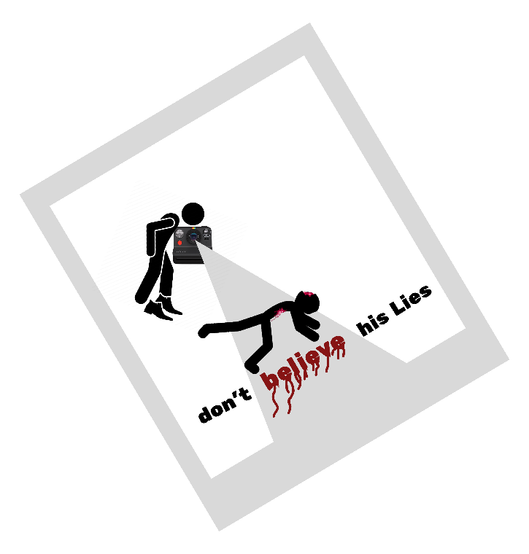

The silhouette of the protagonist hunched over a body with the flash of his polaroid camera shooting a body bleeding on the ground. The words are normal but on a flash the words in the flash are bleeding and drip.

## Illustration styles

Each illustration style follows a conceptual drawing. A context is given which style best fits what idea given.

### Style 1

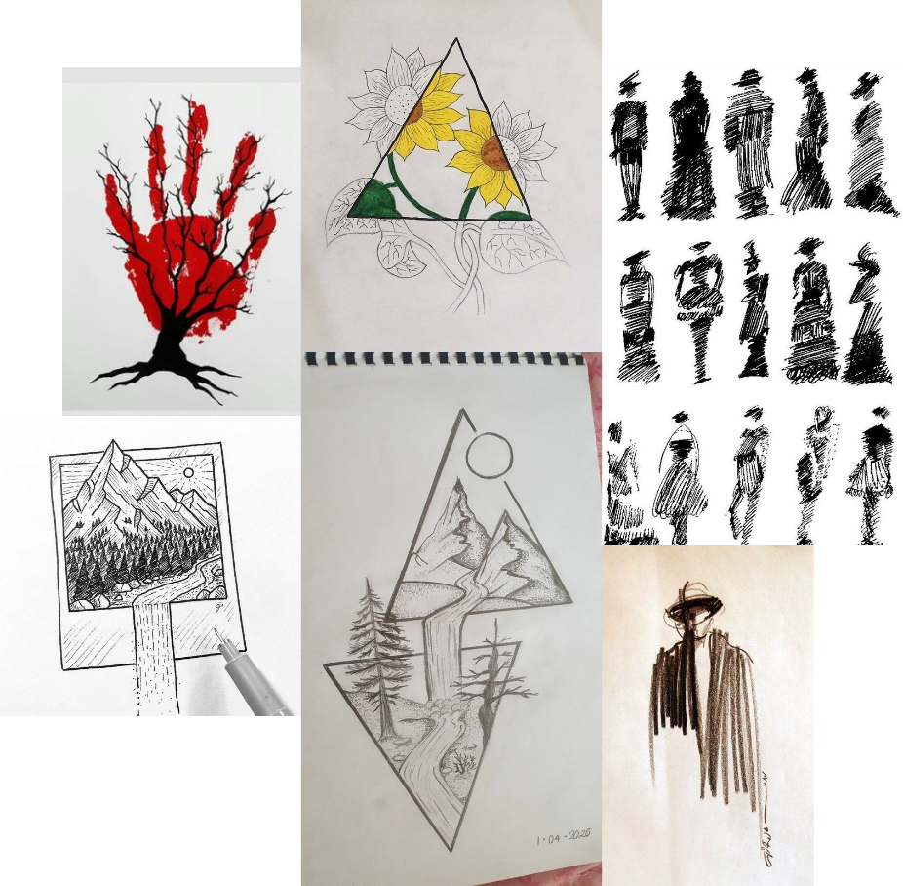

Line art of a frame with the contents overflowing it. The parts inside the shapes are coloured the rest is in drawn lines. Characters can be drawn as scribbles with a backdrop of a shape accentuating their form and intended colours.  
This style works best with: Concept 3, Concept 4, and Concept 5.

### Style 2

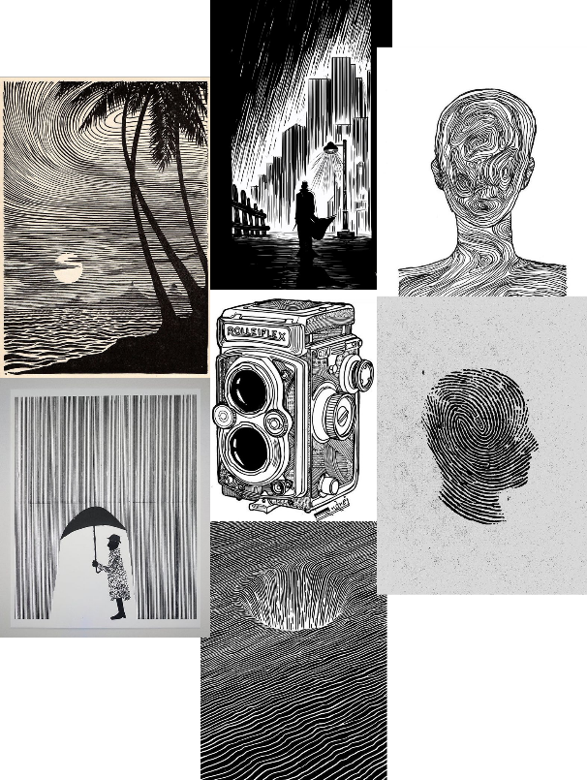

Line drawing, everything is drawn with lines as a texture filling. This can be used ideally to convey the idea of amnesia.  
This style works best with: all Concepts.

### Style 3

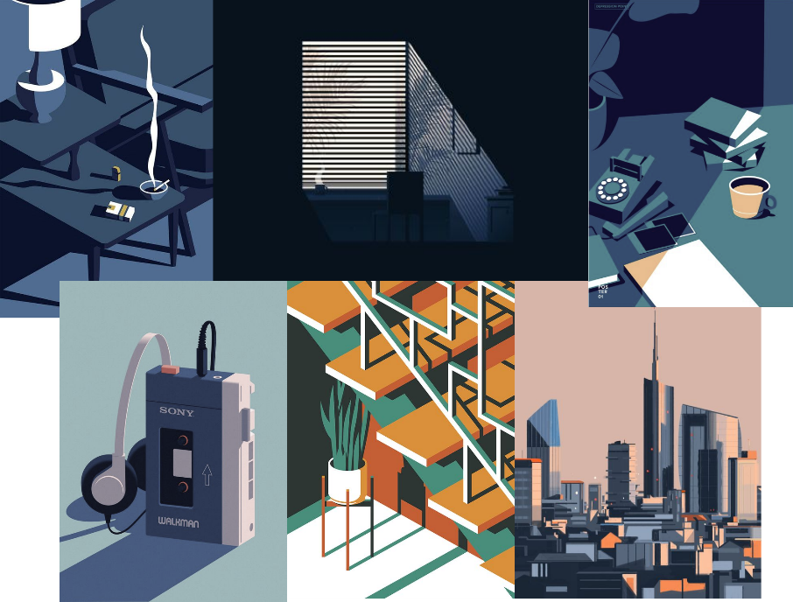

3D stylized vector and flat drawings. This style can convey the felling of the protagonist in his motel room. People can also be stylized this way in dark areas like de deserted house of the movie.  
This style works best with: Concept 2 and Concept 5.

### Style 4

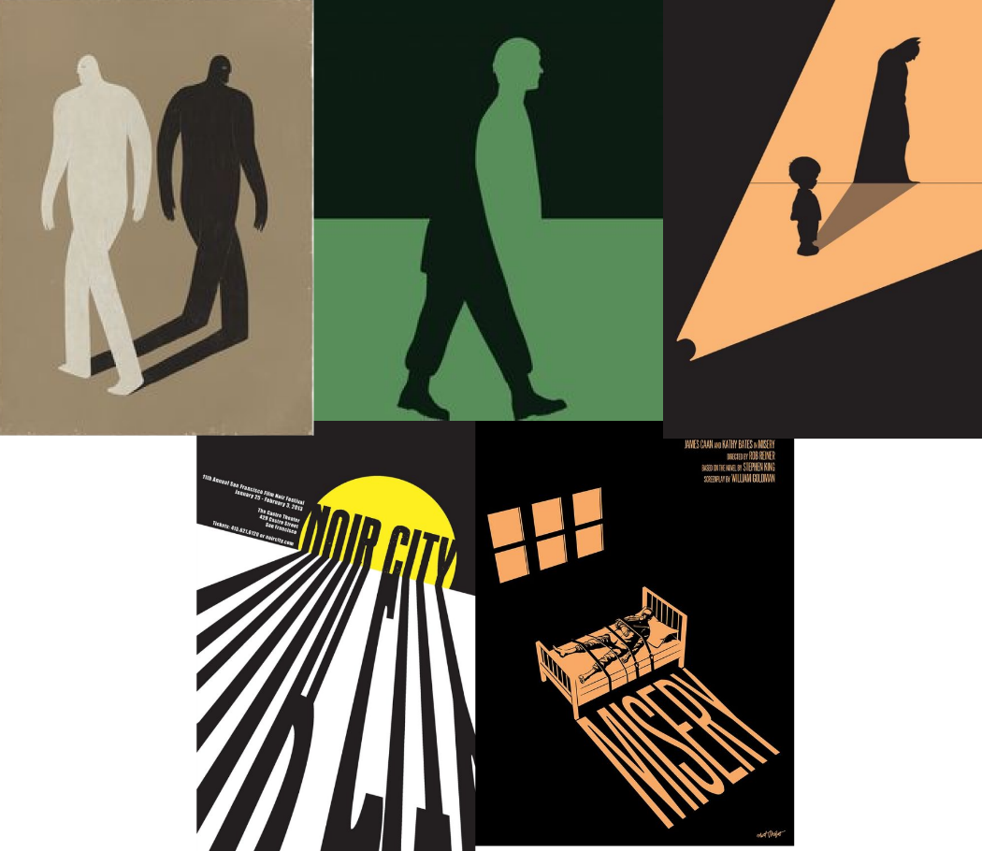

Negatives and shadows, the Protagonist can be an outline in negatives with its key features being highlighted. Other elements can cast shadows in text or other clues.  
This style works best with: Concept 2 and Concept 5.